**Traffic Sign Detection using YOLOv11**

**Data**

The Self Driving Car Dataset is used to train the traffic sign detection model. It contains **4969** total images split into train, validation and test sets with **3530**, **801** and **638** images of dimension 416x416 respectively. The dataset contains images of 15 different traffic signs.

The classes available in the dataset are:

1. All
2. Green Light
3. Red Light
4. Speed Limit 100
5. Speed Limit 110
6. Speed Limit 120
7. Speed Limit 20
8. Speed Limit 30
9. Speed Limit 40
10. Speed Limit 50
11. Speed Limit 60
12. Speed Limit 70
13. Speed Limit 80
14. Speed Limit 90
15. Stop

**Model**

The yolo11n version of the model is used to fine-tune on the dataset. The model was trained for **50** epochs with batch size **16**.

**YOLO11n Evaluation**

Table1: YOLO11n Evaluation

|  |  |  |  |  |  |  |
| --- | --- | --- | --- | --- | --- | --- |
| Class | Images | Instances | Box(P) | R | mAP50 | mAP50-95) |
| all | **801** | **944** | **0.95** | **0.905** | **0.959** | **0.836** |
| Green Light | **87** | **122** | **0.901** | **0.743** | **0.851** | **0.525** |
| Red Light | **74** | **108** | **0.891** | **0.722** | **0.844** | **0.529** |
| Speed Limit 100 | **52** | **52** | **0.95** | **0.942** | **0.989** | **0.889** |
| Speed Limit 110 | **17** | **17** | **0.916** | **1** | **0.986** | **0.915** |
| Speed Limit 120 | **60** | **60** | **1** | **0.943** | **0.995** | **0.908** |
| Speed Limit 20 | **56** | **56** | **0.981** | **0.93** | **0.985** | **0.871** |
| Speed Limit 30 | **71** | **74** | **0.963** | **0.959** | **0.984** | **0.924** |
| Speed Limit 40 | **53** | **55** | **0.935** | **0.945** | **0.988** | **0.887** |
| Speed Limit 50 | **68** | **71** | **0.973** | **0.915** | **0.98** | **0.886** |
| Speed Limit 60 | **76** | **76** | **0.92** | **0.912** | **0.96** | **0.89** |
| Speed Limit 70 | **78** | **78** | **0.987** | **0.962** | **0.981** | **0.9** |
| Speed Limit 80 | **56** | **56** | **0.96** | **0.929** | **0.973** | **0.866** |
| Speed Limit 90 | **38** | **38** | **0.954** | **0.789** | **0.924** | **0.784** |
| Stop | **81** | **81** | **0.975** | **0.982** | **0.988** | **0.929** |

**Detections**

Figure1: speed limit 40 sign Detection

In the image, the detected "Speed Limit 40" sign has a **confidence score of 0.96** (as shown inside the green box).

Figure2: Green Light sign Detection

In this image, the detected **Green Light** has a **confidence score of 0.84**.

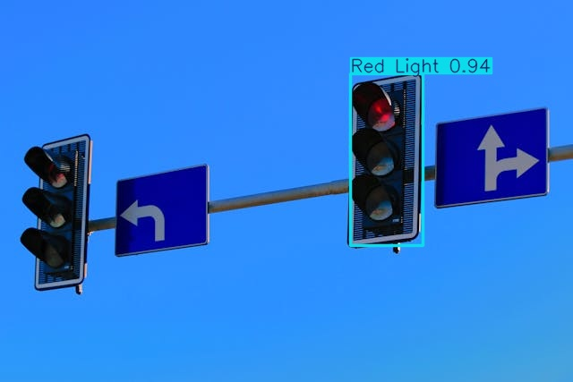Figure 3: Red Light Detection

In this image, the detected **Red Light** has a **confidence score of 0.94**.

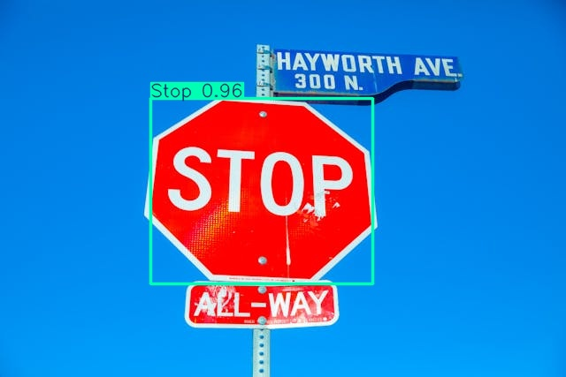

Figure 4: Stop Sign Detection

In this image, the detected **Stop** has a **confidence score of 0.96**

**Conclusion**

This project demonstrates how a fine-tuned YOLOv11 model can be used for traffic sign detection.

Here are a few use cases for this project:

1. Autonomous Vehicle Navigation: The model can be used in self-driving car systems to recognize traffic signs accurately. This would enable autonomous vehicles to follow traffic rules and regulations, analyzing every sign whether it’s about speed limit or stop-and-go indications to navigate the roads safely.
2. Traffic Rule Compliance: This model can be used in driver assistance systems to ensure that drivers comply with all traffic rules. Alerts can be generated when drivers exceed the speed limit or don't stop at red lights, fostering safer roads.
3. Road Safety Training Programs: This model allows Driving schools and automotive companies to build simulations and education programs. These programs can guide new drivers in identifying and responding to different traffic signs, thus enhancing road safety knowledge.
4. Smart City Infrastructure: City authorities could use this model in connected CCTV or IoT infrastructure to track and monitor traffic compliance in real time, helping identify areas with frequent rule violations for potential improvement.
5. Road Network Analysis: Transportation engineering researchers can use this model to analyze how efficiently different sign classes are distributed and recognized around the city. This data can be instrumental in planning more efficient and safer road networks.